*Game Mechanics*

Core game play

* 2D platformer
* Puzzles
* Room by room
  + Finish a puzzle in a room, then move to the edge of the screen and complete the next puzzle

Game Flow

* Player movement with arrow keys
* Jump with the spacebar
* Player can hover for a short period of time
* Player can hover by pressing space

Game Play Elements

* Jump Mechanic
  + When up arrow is pressed, the character lifts off the ground and, when it reaches its peak, falls back down onto the ground.
* Ground
  + Character will be able to collide with the ground, as well items or other things(like springs)
* Jetpack
  + Jumping and then holding space will allow the character to hover for a few seconds. Jetpack can be reused. To reuse jetpack, the character has to stand on stable ground. If the character is moving in the jump motion and activates the jetpack, the character will continue moving in that direction.
* Bounce Platform
  + Some sort of platform that forces the player to jump and disappears for a short time on collision.

|  |  |  |  |  |  |  |  |
| --- | --- | --- | --- | --- | --- | --- | --- |
|  | **Day 1** | **Day 2** | **Day 3** | **Day 4** | **Day 5** | **Day 6** | **Day 7** |
| **Week 1** | Lecturers spoke to us about project |  | Put into groups.  Spoke to the group about game and how to make it. | Start working on the game |  |  |  |
| **Week 2** | Class/Group meeting.  Assign certain parts to certain members. |  | Class/Group meeting.  Continue working on their individual parts. |  | Call a meeting to make sure that everything is going well. |  |  |
| **Week 3** | Class/Group meeting.  Play test and try finish up. |  | Class/Group meeting.  Finish the game. | Individually finish other pieces for the assessment. |  |  |  |
| **Week 4** |  |  |  |  |  |  |  |

What actually happened.

Planning

|  |  |  |  |  |  |  |  |
| --- | --- | --- | --- | --- | --- | --- | --- |
|  | **Day 1** | **Day 2** | **Day 3** | **Day 4** | **Day 5** | **Day 6** | **Day 7** |
| **Week 1** | Lecturers spoke to us about project |  | Put into groups.  Spoke to the group about game and how to make it. | Start working on the game |  |  |  |
| **Week 2** | Class/Group meeting.  Assign certain parts to certain members. |  | Class/Group meeting.  Continue working on their individual parts.  Something went wrong with the github. |  | Call a meeting to make sure that everything is going well.  Group decides to use the old platformer level’s code for the new game |  |  |
| **Week 3** | Class/Group meeting.  Added a new repository for the old-new game. |  | Class/Group meeting.  Got everything working finally and get the jetpack working. | Panic and try to get the rest of the game finished. |  |  |  |
| **Week 4** | Class/Group meeting.  Finish everything else quickly for assessment. |  |  |  |  |  |  |

Target Audience

* This game is targeted towards an age group of 7 – 16
* This group have lots of free time to spare that they can use to play this game.
* These kids also don’t have a lot of money, so this game is free.

Changes

* We decided not to add multiple levels into this game, sticking with just one simple level. This is due to the difficulty of this process and the time restraint.
* Other objects such as springs and bouncing platforms were removed due to difficulty.

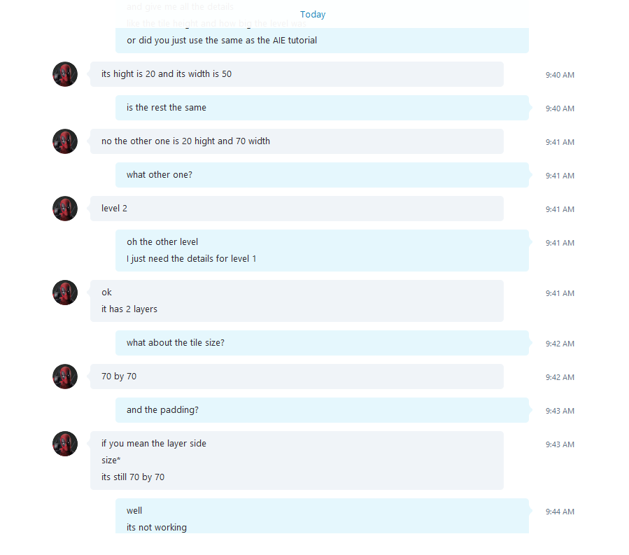Signs of Teamwork

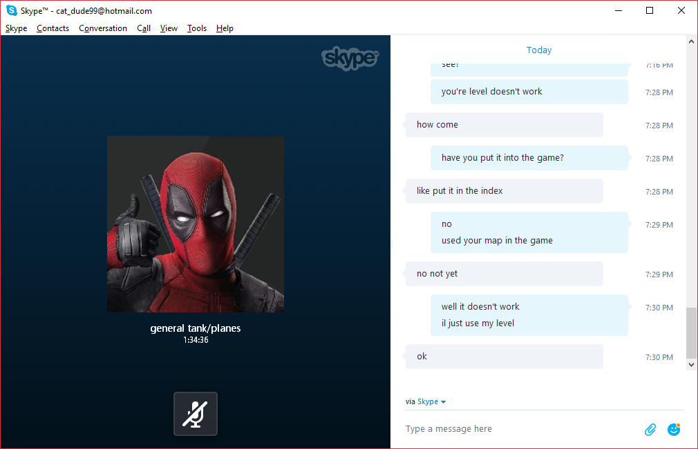

Links:

Github: <https://github.com/GregosaurusRex/green-team-2>

Trello: <https://trello.com/b/eDIkh3PS/green-team>